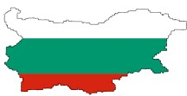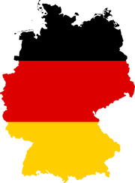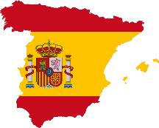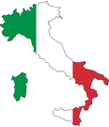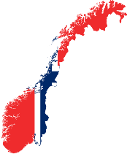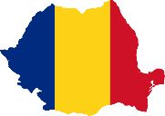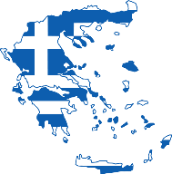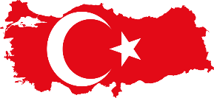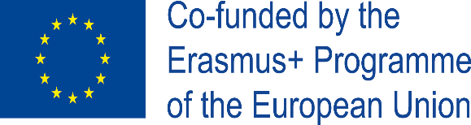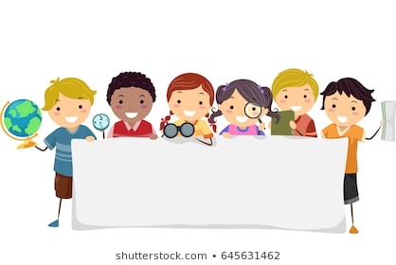

Strategic partnerships

Inter-school exchange partnerships

#### **“GYMNASIUM OF KORONI”**

#### **JUNIOR HIGH SCHOOL**

#### 

#### **KORONI, GREECE**

#### **KORONI**

#### **gym**-koron.mes.sch.gr

**ERASMUS+**

**KA229**

**2019-2021**



Erasmus+ is the EU Programme in the fields of education, training, youth and sport for the period 2014-2020[1](https://ec.europa.eu/programmes/erasmus-plus/programme-guide/part-a_en" \l "footnote1_blko3es" \o "REGULATION (EU) No 1288/2013 OF THE EUROPEAN PARLIAMENT AND OF THE COUNCIL of 11 December 2013 establishing 'Erasmus+': the Union programme for education, training, youth and sport (http://eur-lex.europa.eu/LexUriServ/LexUriServ.do?uri=OJ:L:2013:347:0050:0073:EN:PDF)). Education, training, youth and sport can make a major contribution to help tackle socio-economic changes, the key challenges that Europe will be facing until the end of the decade and to support the implementation of the European policy agenda for growth, jobs, equity and social inclusion.Fighting high levels of unemployment - particularly among young people - is one of the most urgent tasks for European governments. Too many young people leave school prematurely running a high risk of being unemployed and socially marginalised. The same risk threatens many adults with low skills. Technologies are changing the way in which society operates, and there is a need to ensure the best use is made of them. EU businesses need to become more competitive through talent and innovation.Europe needs more cohesive and inclusive societies which allow citizens to play an active role in democratic life. Education, training, youth work and sport are key to promote common European values, foster social integration, enhance intercultural understanding and a sense of belonging to a community, and to prevent violent radicalisation. Erasmus+ is an effective instrument to promote the inclusion of people with disadvantaged backgrounds, including newly arrived migrants.Another challenge relates to the development of social capital among young people, the empowerment of young people and their ability to participate actively in society, in line with the provisions of the Lisbon Treaty to "encourage the participation of young people in democratic life in Europe". This issue can also be targeted through non-formal learning activities, which aim at enhancing the skills and competences of young people as well as their active citizenship. Moreover, there is a need to provide youth organisations and youth workers with training and cooperation opportunities, to develop their professionalism and the European dimension of youth work.Well-performing education and training systems and youth policies provide people with the skills required by the labour market and the economy, while allowing them to play an active role in society and achieve personal fulfilment. Reforms in education, training and youth an strengthen progress towards these goals, on the basis of a shared vision between policy makers and stakeholders, sound evidence and cooperation across different fields and levels.The Erasmus+ Programme is designed to support Programme Countries' efforts to efficiently use the potential of Europe’s talent and social assets in a lifelong learning perspective, linking support to formal, non-formal and informal learning throughout the education, training and youth fields. The Programme also enhances the opportunities for cooperation and mobility with Partner Countries, notably in the fields of higher education and youth.

2. Learning Teaching and Training activities in Latvia with participation of four teachers from Turkey and Romania  
3. Learning Teaching and Training activities in Romania with participation of four teachers from Turkey and Latvia  
3. Preparation of the plans and activities which are going to be applied in cooperation with the partners.  
4. Implementation of the plans and activities by every partner.  
5. Observation of the activities via teleconferences.  
EVALUATION:  
1. Learning Teaching Training activities in Turkey with the participation of four staff members from Latvia and Romania for observation and evaluation.  
2. Constitution of an Evaluation Commission with the participation of teachers from Turkey, Romania and Latvia.  
3. Preparing a report of the activities in the form of booklet   
DISSEMINATION:  
-The project will be introduced on e-twinning.  
-Similar studies will be made at the other school.  
-Meetings will be held by the participation of the parents' of the students

#### **“GYMNASIUM**

#### **OF KORONI”**

#### **JUNIOR HIGH SCHOOL**

#### 

#### **KORONI GREECE**

GIS-GENDER INEQUALITY IN SCHOOLS

**2019-1-ES01-KA229-065694\_5**

**2019-2021**

 Among students,girl students generally tend to avoid or grow hesitation towards scientific studies

and STEM studies.The tendency towards girls are the same too.The families,teachers or employers

do not think or behave equally as they strongly believe that girls and boys have different roles in the

society and the qualifications and jobs have genders.If we do not change our attitude and ignore the

scientific developments, girl will face crucial problems of unemployments and excluding in working

life.Seeing the hesitation and avoiding joining STEM or Robotic coding activities among girls or

strong prejudices and dicrimination toward girls in using computer technology and applying it their

studies, have run us preparing us and motivate the students to act and remove all the prejuices. We aim to;

-build up a ‘team of researchers’ who can analyze and focus on the main problems related to Gender

Inequality in their schools and in the Society they live;

- help students to investigate the reasons why few girls and female students are involved in STEM; .

- enhance the knowledge of cultural heritage through the study of own’s traditions and approaches to

different life styles in order to understand how we can solve the problem of gender inequality finding

positive attitudes/aspects to spread and negative ones to avoid or fight.

- fight against stereotypes creating padlets, posters, video and all the webtools 2 which can be used

for this purpose.

**PARTNERS**

* IES Alpujarra, Spain
* SOU ‘Hristo Botev’, Bulgaria
* Istituto d’Istruzione Superiore Lorenzo Gigli
* Gymnasium of Koroni, Greece
* Osman Gazi Anadolu Lisesi, Turkey
* 15 Temmuz Sehitleri Fen Lisesi



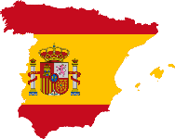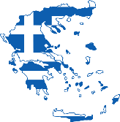

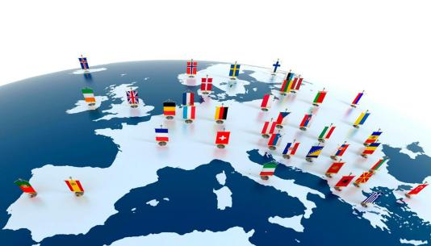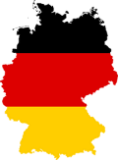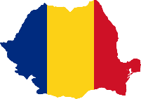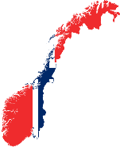

WHY SHOULD STUDENTS TAKE PART

There are numerous other advantages for those who take part, including:

* Improved academic attainment: a higher proportion of those who study abroad have been found to achieve a First Class or Upper Second Class degree compared with those who stay in one place
* Enhanced employment prospects: Erasmus alumni are 44% more likely to hold managerial positions than their peers 10 years after graduation. Evidence also shows that students who have done an Erasmus placement find work more quickly after graduation
* Important language and inter-personal skills: studies have found students taking part in Erasmus have improved personal and soft skills, self-confidence, intercultural understanding and maturity due to their time spent abroad.

Whilst the Erasmus programme is best known for supporting student placements abroad, funding is also available to support staff mobility, joint masters courses and collaborative projects, including with universities outside the EU, amongst other initiatives.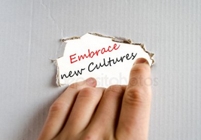

Important language and inter-personal skills: studies have found students taking part in Erasmus have improved personal and soft skills, self-confidence, intercultural understanding and maturity due to their time spent abroad. As our graduates are increasingly working in multi-lingual and

**Touropean  
2019-1-DE03-KA229-059776\_2**

**2019-2021**

We would like to draw teenagers' attention to their own and their partner schools' surroundings in order to get them involved in the European cultural heritage. This will be achieved not only by visiting but also by assessing touristic attractions in different fields of interest.

In our project the students will be involved in an open education and creative use of digital media when solving their task of evaluating different touristic sights from a teenager's point of view. In today's digital era all sources of innovative practices such as creating a video clip, making a podcast, a slide show, a presentation or a video are welcome. ICT skills as well as presentation and rhetoric skills which are crucial in todays labor market will be fostered.

Our main objective is to make young people aware of the social and educational value of European culture heritage, its contribution to job creation, economic growth and social cohesion.

All of the results will be put together. So the final product will be a diverse Travel Blog which will be published on our websites (project and schools) as well as on eTwinning.

Another important objective is to feature the economical benefits of the tourist industry which provide a wide range of jobs. The students will be exposed to various career options. They will have the chance to deal with different people and mentalities and that will open their eyes to ideas, opportunities and possibilities beyond what they may know exist. This will inspire and motivate our students to do well at school and in that way help combating failure in education and early school leaving.

<https://touropean.weebly.com/>

**PARTNERS**

* Integrierte Gesamtschule Thaleischweiler-Fröschen, Germany
* Lillesand Ungdomsskole, Norway
* Gymnasium of Koroni, Greece
* IES Núm. 1 Universidad Laboral, Spain
* “Elena Farago” Secondary School, Romania